**UNIVERSITATEA “POLITEHNICA” DIN BUCURESTI**

**Facultatea de Electronica, Telecomunicatii si Tehnologia Informatiei**

**Proiect Semnale si programare**

**Analiza semnalelor in Matlab**

**Haiducescu Andrei Gr. 421F**

2021

Cuprins

Introducere 3

Date si cerinta 5

Notiuni teoretice 7

Structura progamului 18

Rezolvarea cerintelor 20

1. x(t) 20
2. xi(t), yi(t), zi(t) 21
3. Mono alternanta si dubla alternanta 26
4. xpar(t), ximpar(t), x(2t), x(2t-1) etc 32
5. Calculul componentei continue 35
6. xi(t), yi(t), zi(t) fara componenta continua 36
7. Calculul componentei continue in matlab 37
8. Calculul puterii in matlab 37

i) w1(t), w2(t), w3(t) 39

Concluzii 42

Bibliografie 43

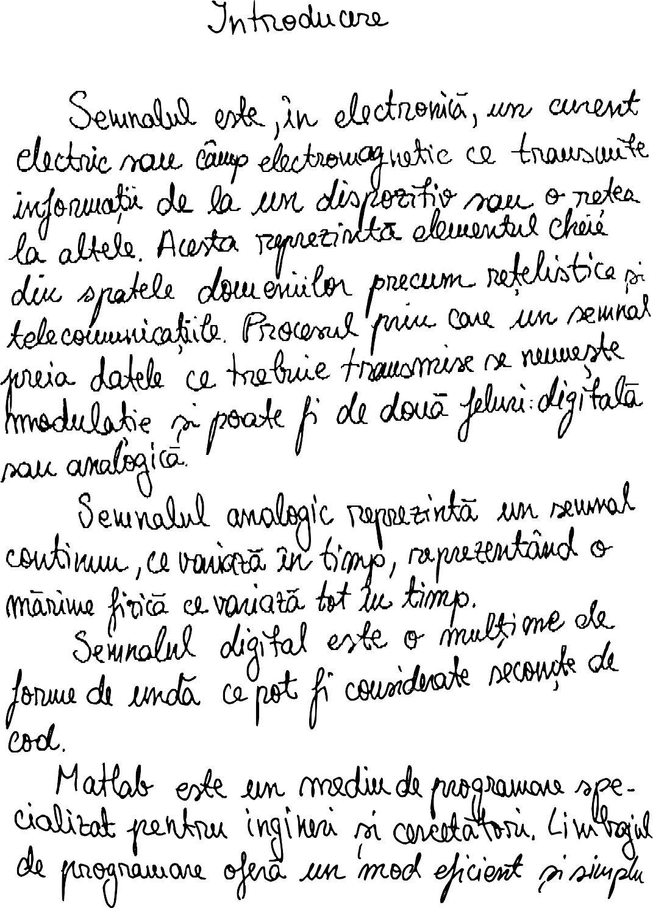

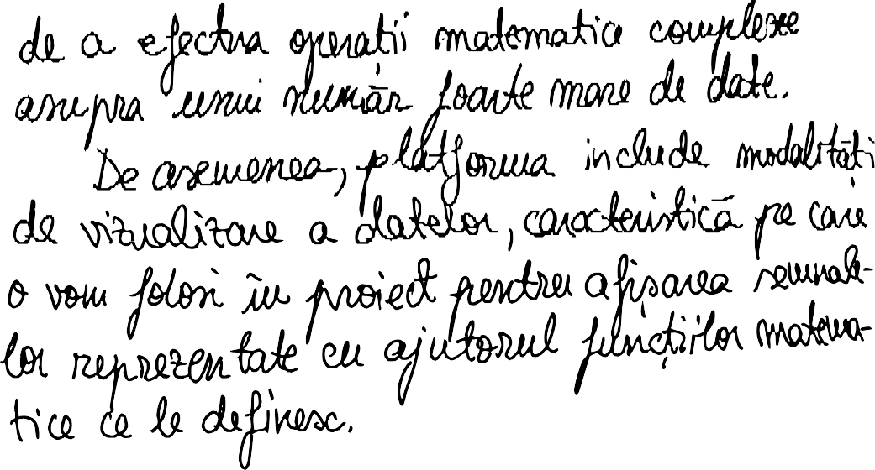

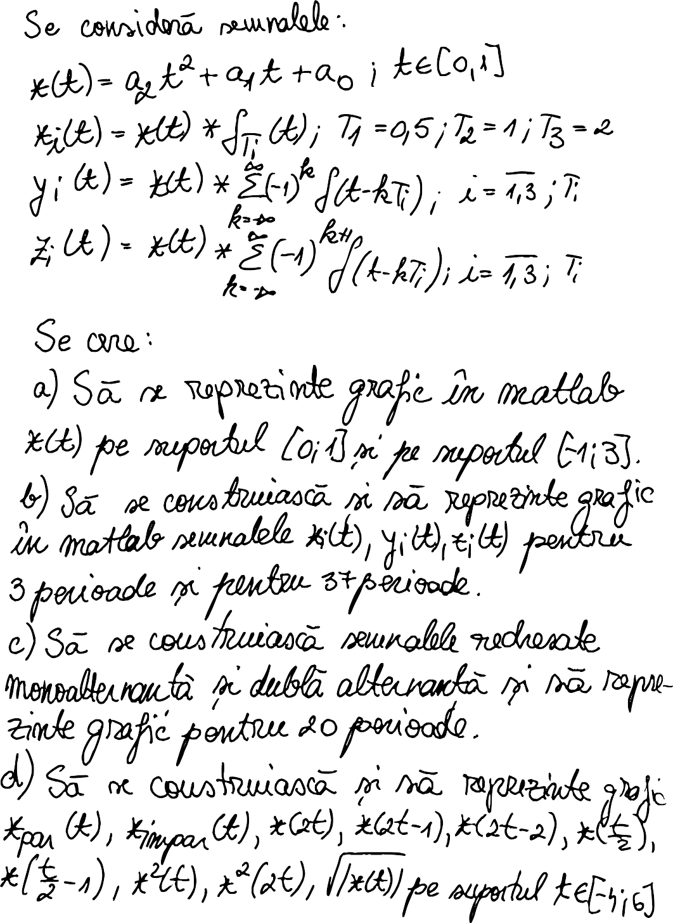

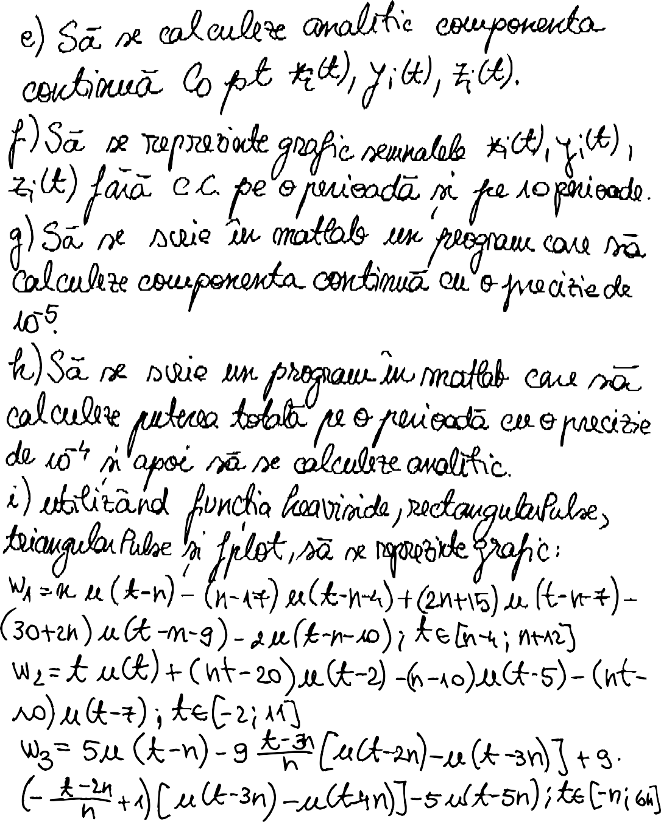

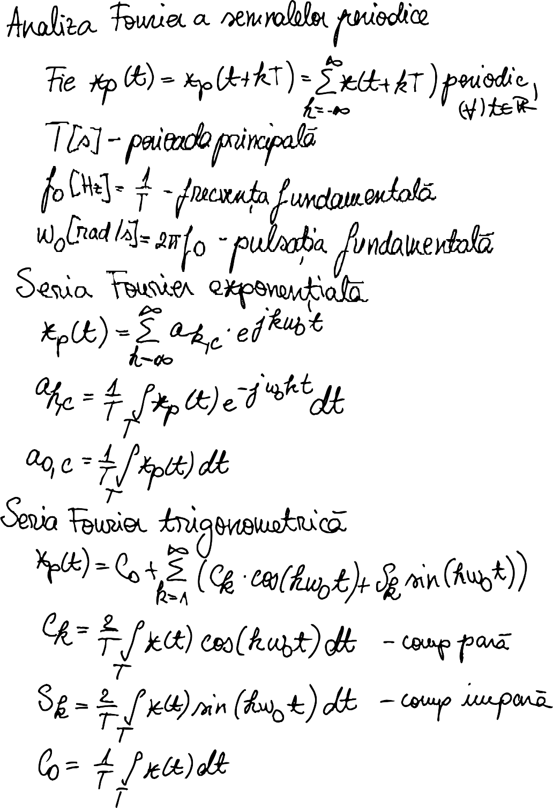

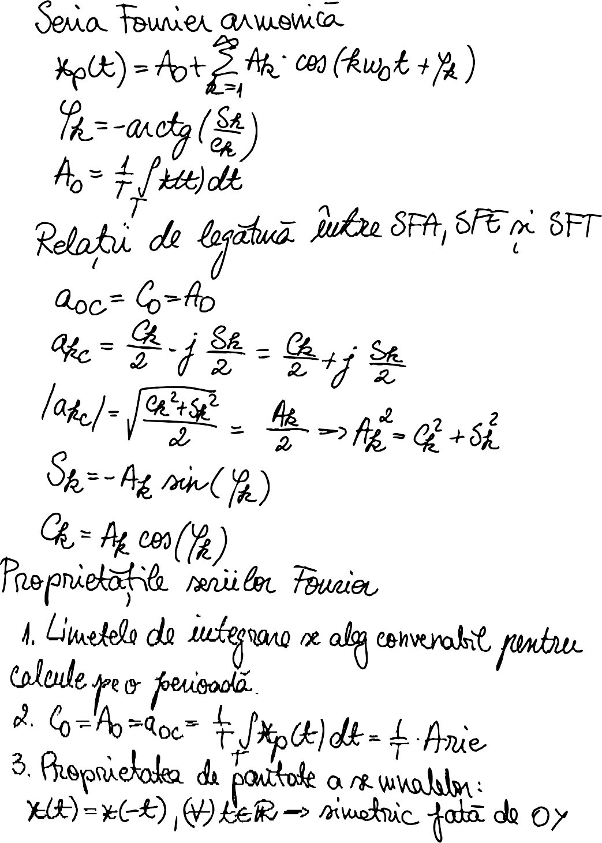

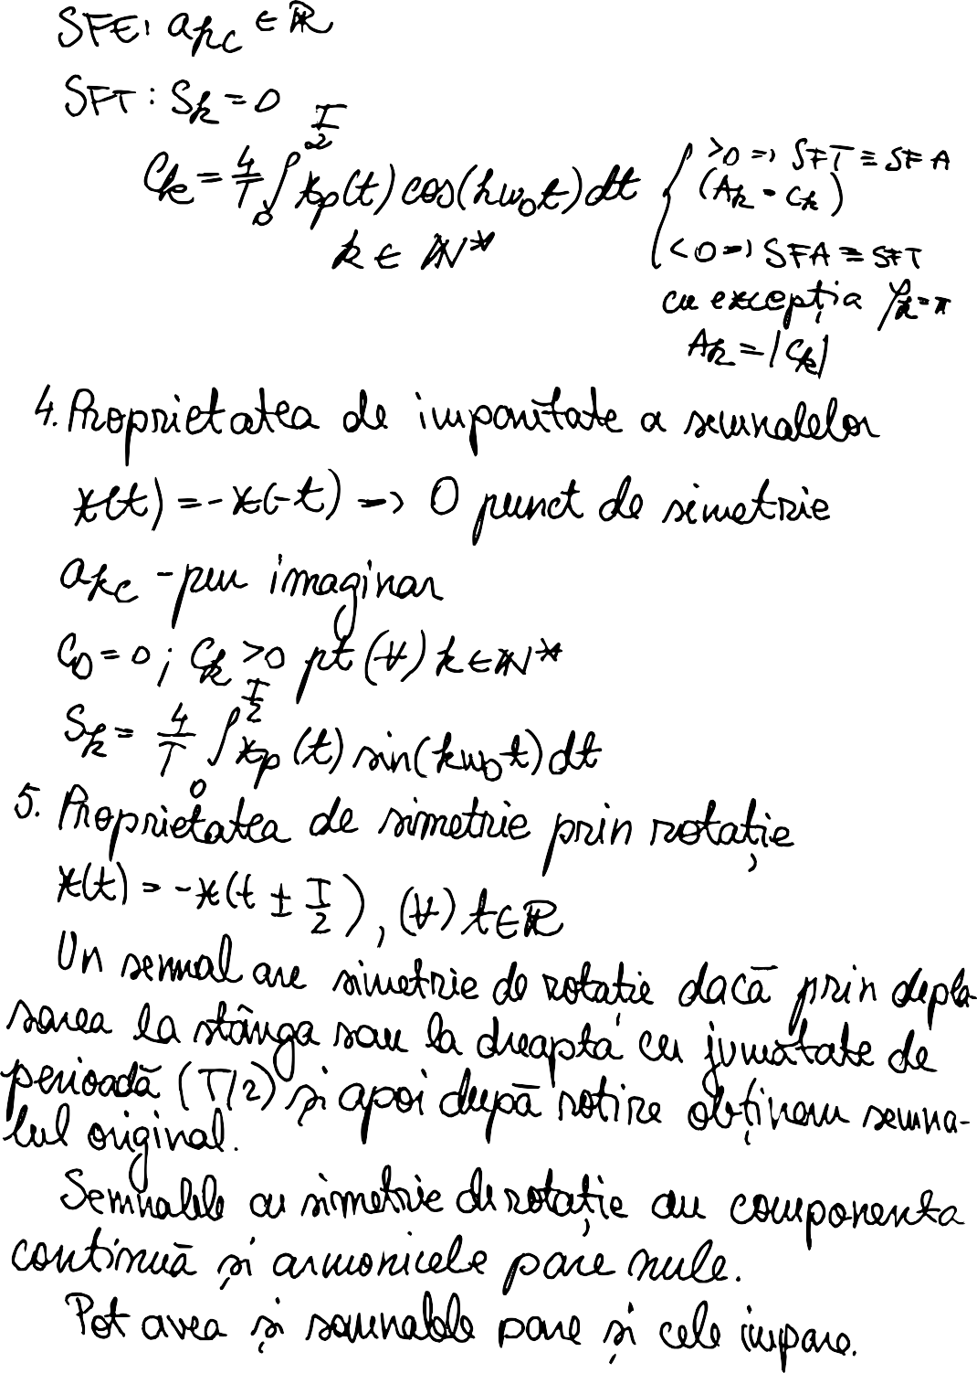

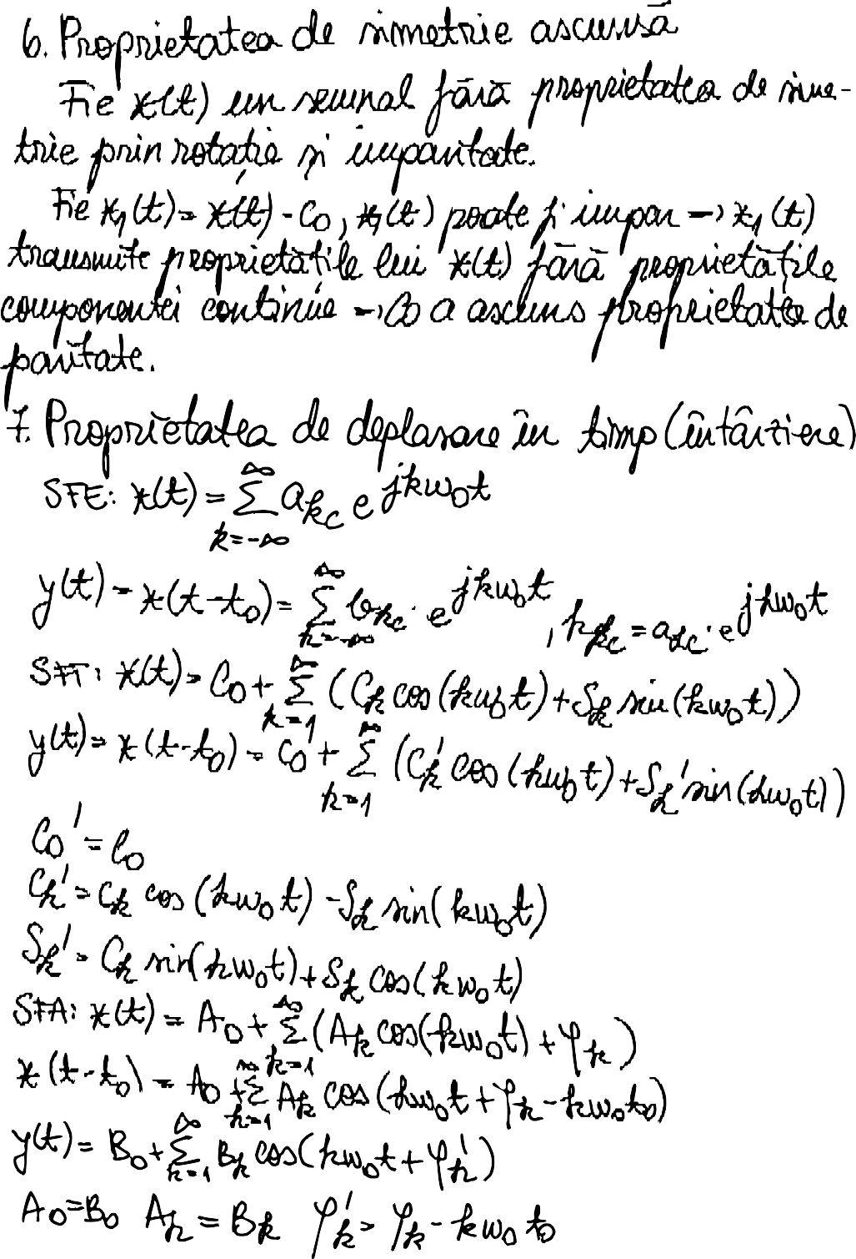

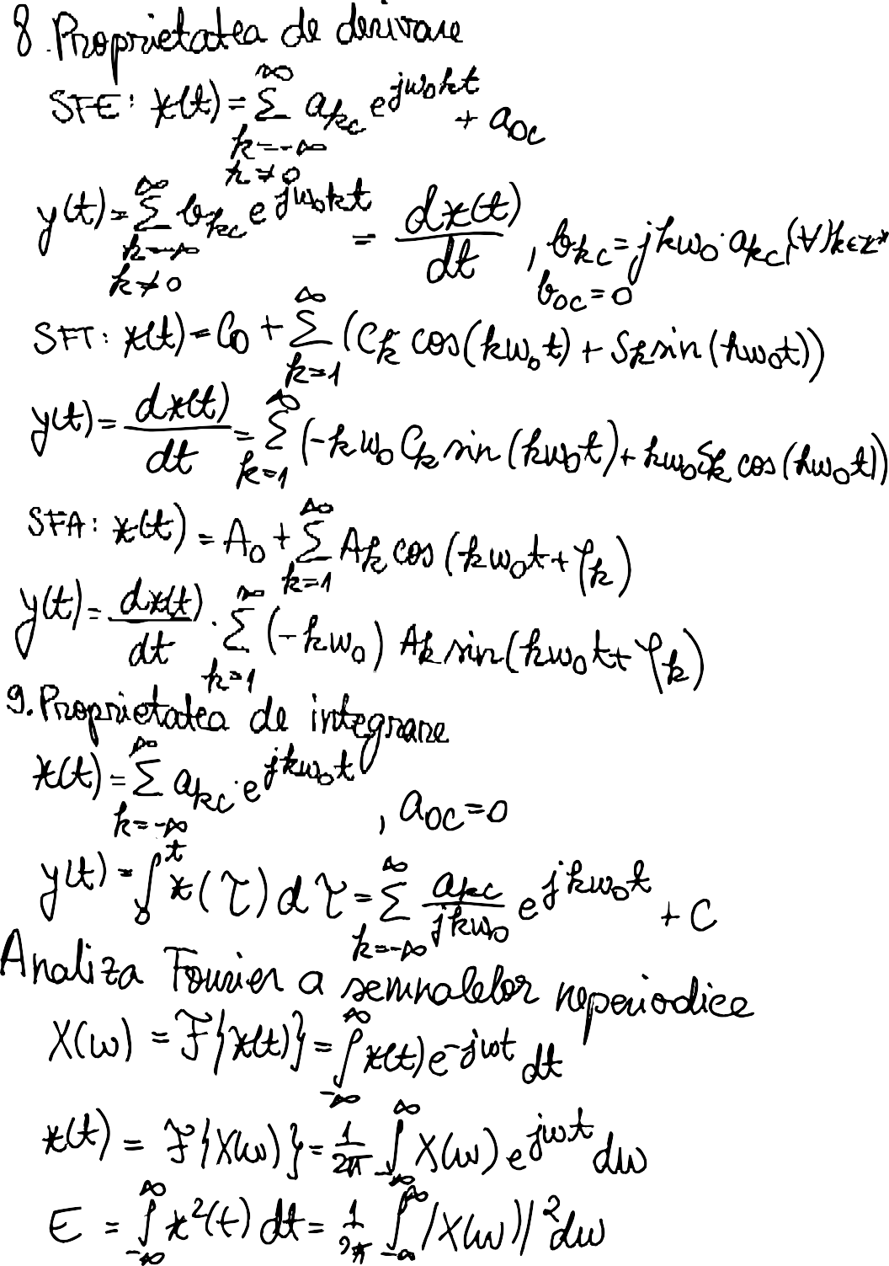

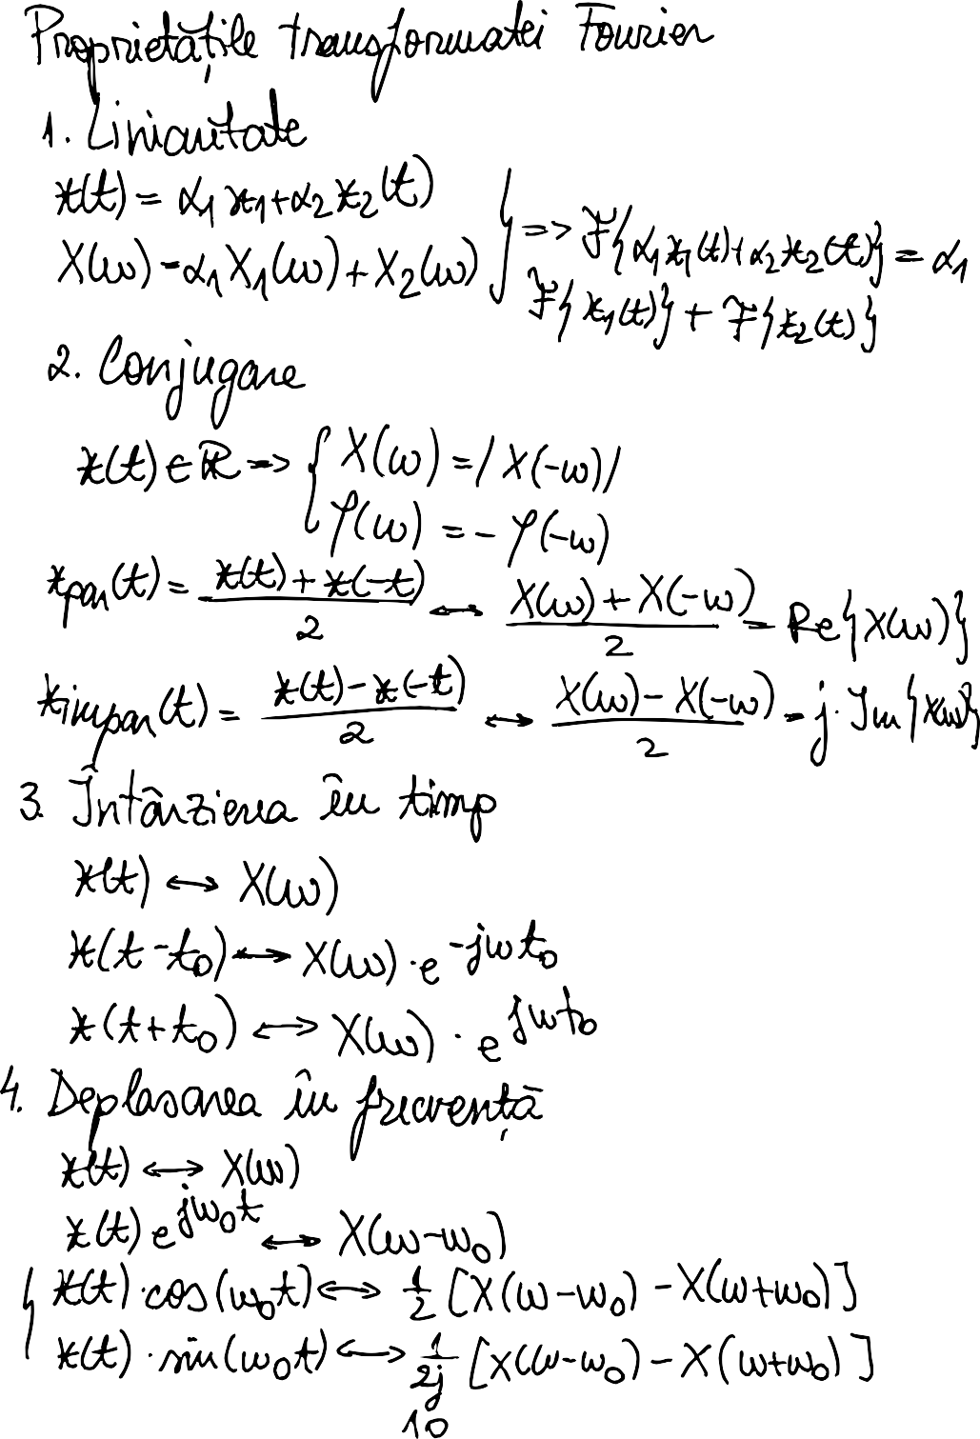

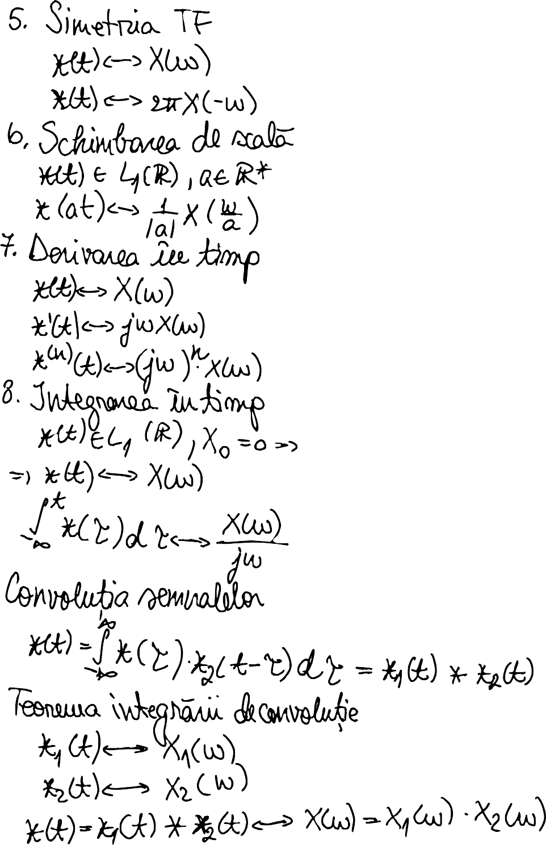

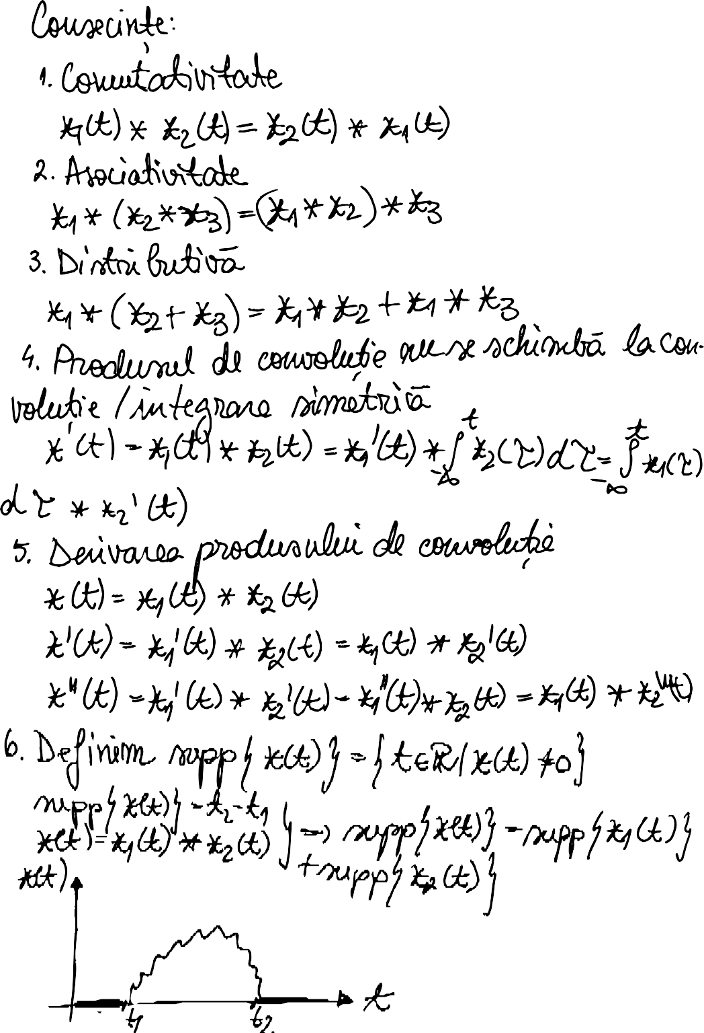

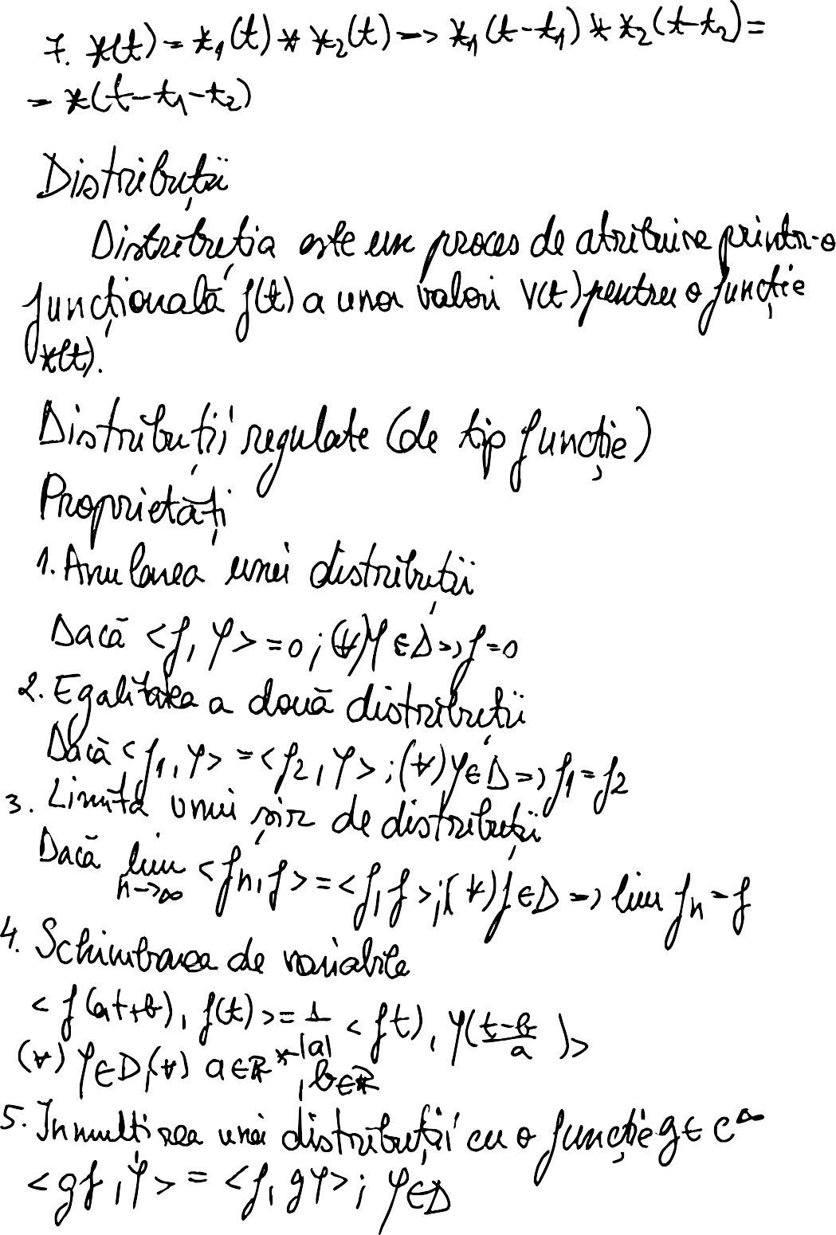

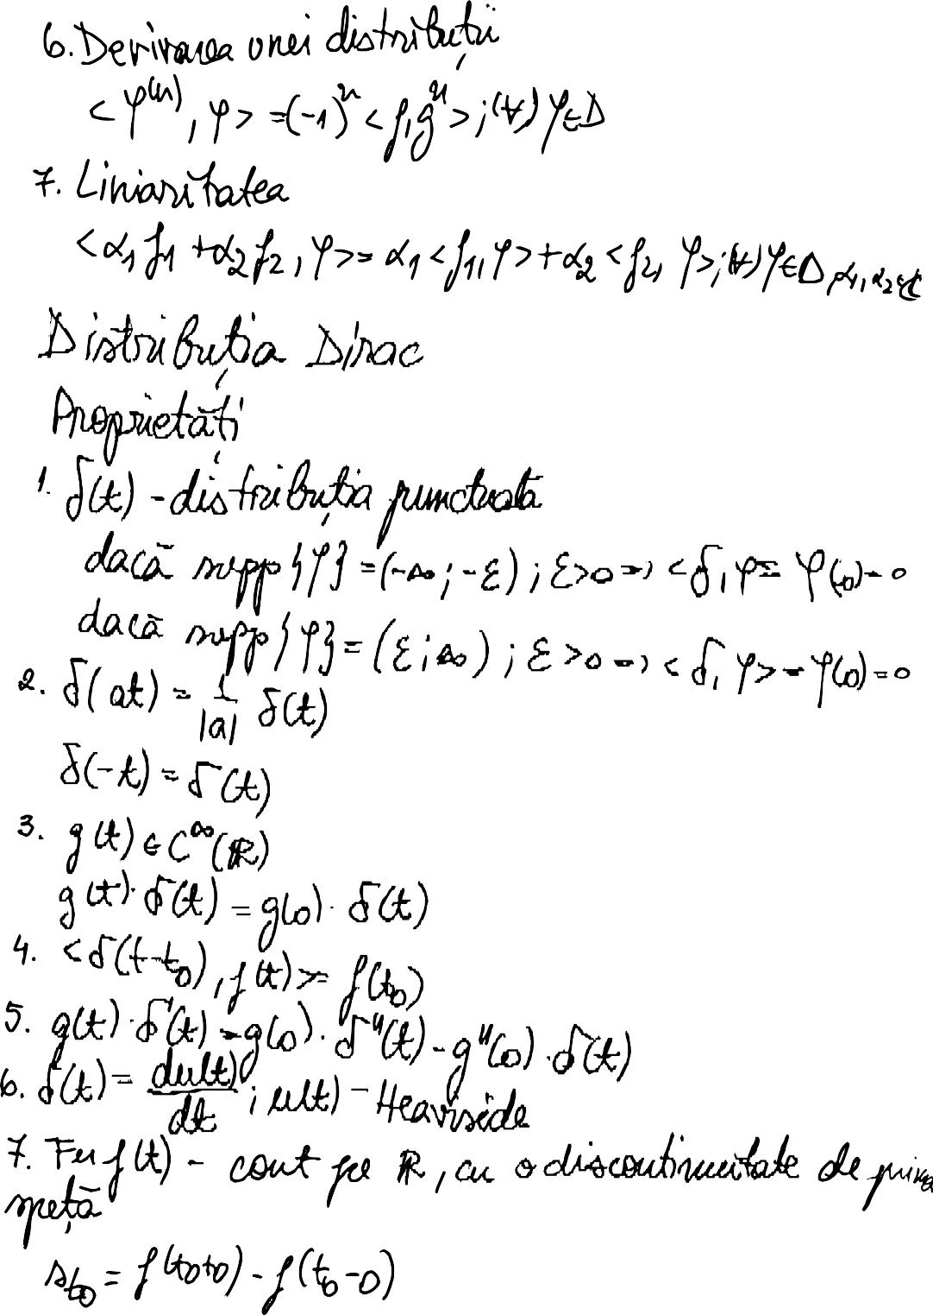

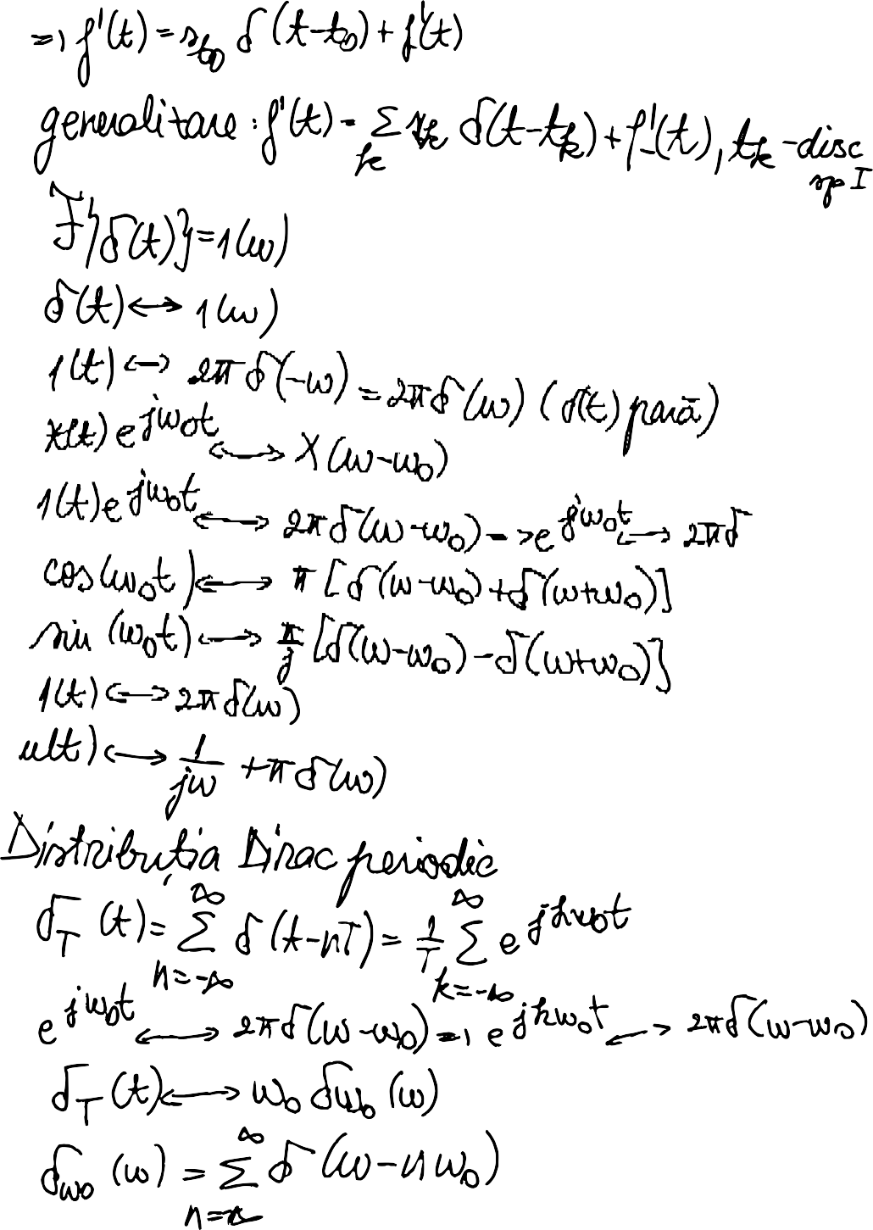

# Structura programului

**Am citit variabilele a0, a1 si a2 din fisierul excel.**

read_variables.m function [a2, a1, a0] =

readVariables(file, sheet, number) table = readtable(file, 'Sheet', sheet); variable_table = table(number,2:4);

a2 = str2double(variable_table.a2); a1 = str2double(variable_table.a1); a0 = variable_table.a0;

end

|  |  |  |  |
| --- | --- | --- | --- |
| **n** | **a2** | **a1** | **a0** |
| 4 | 11,333 | - 0.0469 | 0.4118 |

# Am definit fiecare variabila de care este nevoie pe parcursul programului.

main.m

file = 'Teme proiect SP 421F 422F.xlsx'; number = 4;

sheet = 'Sheet1';

[a2, a1, a0] = readVariables(file, sheet, number);

t1 = linspace(0, 1); t2 = linspace(-1, 3); T = [0.5, 1, 2];

period = 1;

number_of_periods = [3, 37, 20, 1, 10]; s = linspace(-4, 6);

CC = [1.827839, 4.166016, 2.083008];

precision = 100000;

precision_t = linspace(0,1,precision);

**Am creat o functie care sa schimbe designului graficelor afisate.**

design_graph.m

function [] = design_graph(x_label, y_label, title_)

grid minor; xlabel(x_label); ylabel(y_label); title(title_); end

# Am creat o functie care sa afiseze un semnal dat ca argument.

display_signal.m

function [] = display_signal(signal, T, j, i, name, number_of_periods, period, signal_i)

[xi, si] = signal_i(signal, T(j), number_of_periods(i), period); subplot(3, 1, j);

plot(si, xi);

y_label = name + string(j) + '(t)'; title_ = 'Reprezentarea grafica ' + y_label + ' pe ' + string(number_of_periods(i)) + ' perioade';

design_graph('t', y_label, title_); end

**Apasarea tastei Enter continua afisajul semnalelor de la o cerinta la alta.**

main.m input('next');

# Rezolvarea cerintelor

# x(t)

% MAIN SIGNAL

plot(t1, signal_main(a0, a1, a2, t1)); design_graph('t', 'x(t)', 'Reprezentarea grafica x(t)');

input('next');



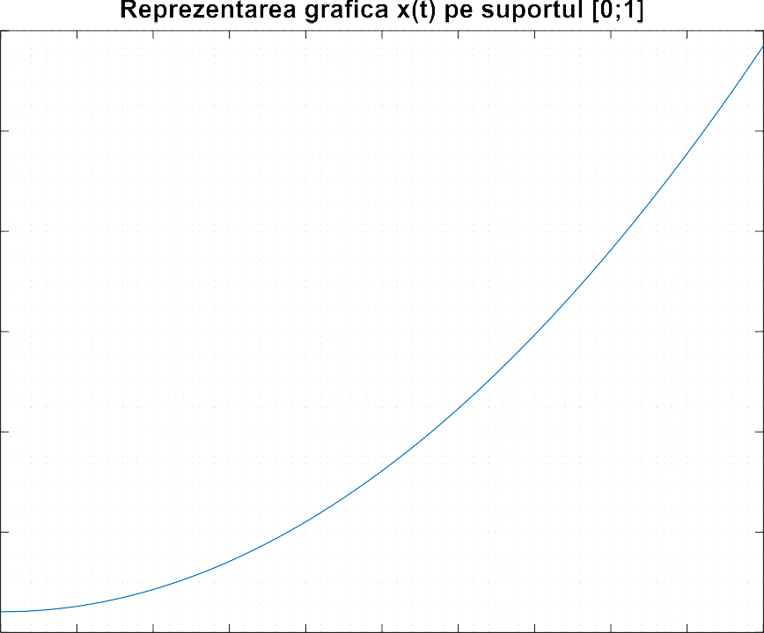

plot(t2, signal_main(a0, a1, a2, t2));

design_graph('t', 'x(t)', 'Reprezentarea grafica x(t) pe suportul [-1;3]'); input('next');



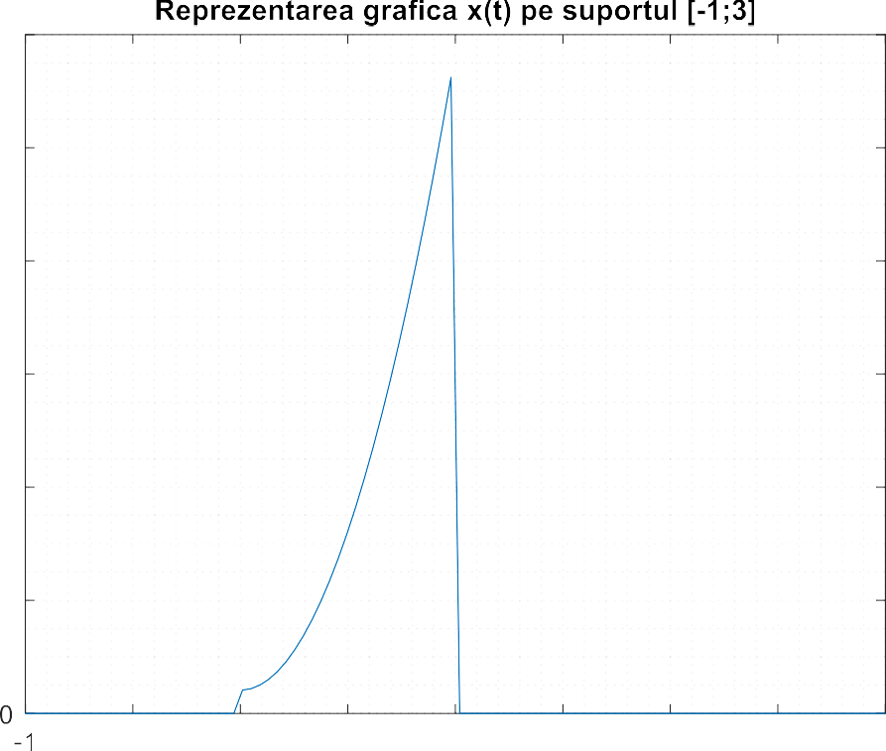



# xi(t), yi(t), zi(t)



signal_xi.m

function [xi, si] = signal_xi(x, T, number_of_periods, period)

% return signal xi if T > period

for i = 1:100 * T

if i > 100 * (T - period) x(i) = 0;

end

end

end

xi = x'*ones(period, period * number_of_periods);

xi = xi(:); if T > period

si = linspace(0, T * number_of_periods, 100 * number_of_periods * T); else

si = linspace(0, T * number_of_periods, 100 * number_of_periods);

end

si = si(:);

end

% xi signal for i = 1:2

for j = 1:3

name = 'x';

signal = signal_main(a0, a1, a2, t1);

display_signal(signal, T, j, i, name, number_of_periods, period, @signal_xi);

end input('next');

end

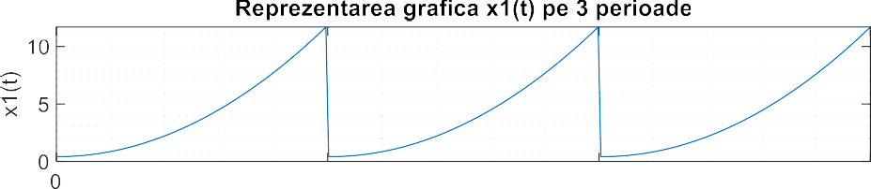



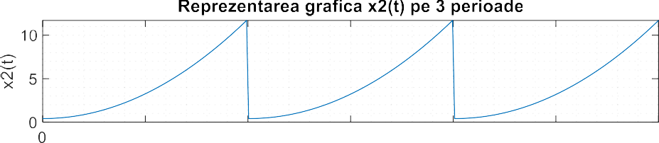



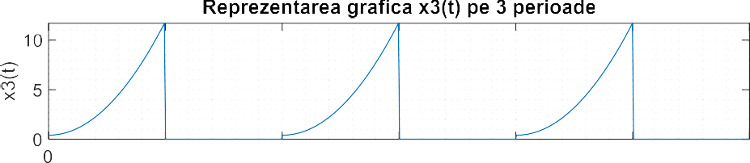



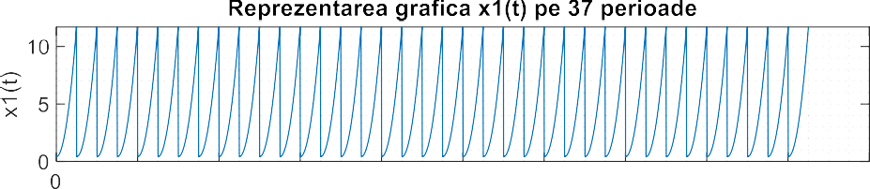



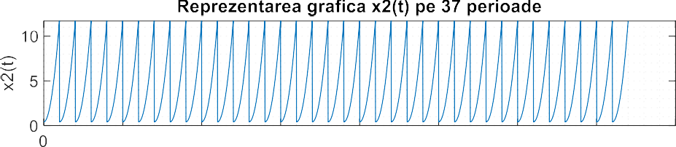



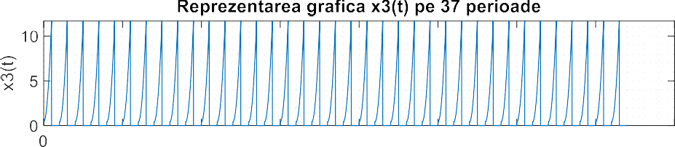



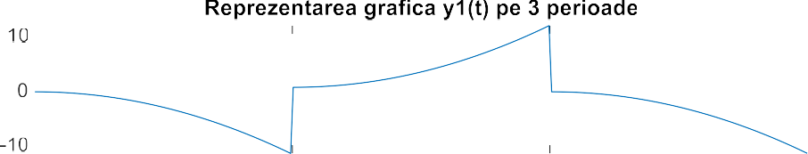

% yi signal for i = 1:2

signal_yi.m

function [yi, si] = signal_yi(x, T, number_of_periods, period)

% return signal yi

yi = x'*ones(period, period * number_of_periods);

for i=1:number_of_periods for j=1:100

yi(j,i)=((-1)^i)*yi(j,i); if T > period

if j > 100 * period/T yi(j,i) = 0;

end

end

end

end

yi = yi(:);

si = linspace(0, T * number_of_periods,

100 * number_of_periods); si = si(:);

end

for j = 1:3

name = 'y';

signal = signal_main(a0, a1, a2, t1);

display_signal(signal, T, j, i, name, number_of_periods, period, @signal_yi);

end input('next');

end

|  |
| --- |
|  |
|  |
|  |
|  |
|  |
|  |

   



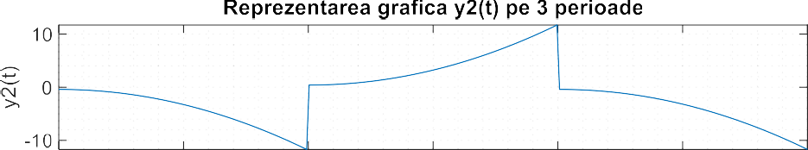

      



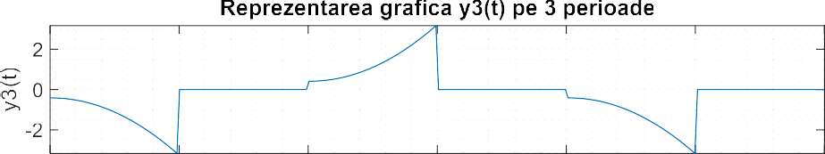

      



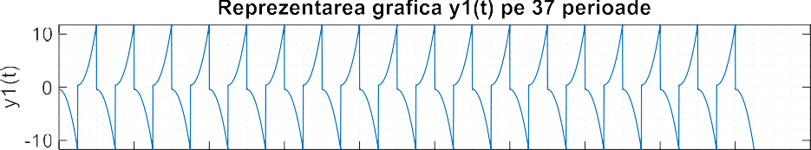

          



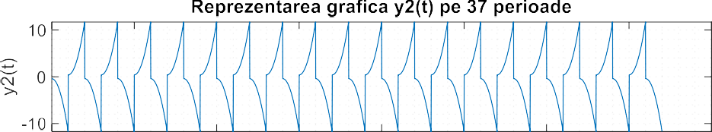

        



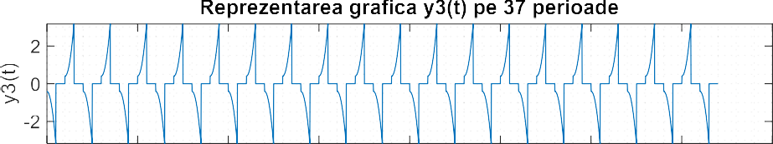

        



% zi signal for i = 1:2



signal_zi.m

function [zi, si] = signal_zi(x, T, number_of_periods, period)

% return signal zi

zi = x'*ones(period, period * number_of_periods);

for i=1:number_of_periods for j=1:100

zi(j,i)=((-1)^(i+1))*zi(j,i); if T > period

if j > 100 * period/T zi(j,i) = 0;

end

end

end

end

zi = zi(:);

si = linspace(0, T * number_of_periods,

100 * number_of_periods); si = si(:);

end

for j = 1:3

name = 'z';

signal = signal_main(a0, a1, a2, t1);

display_signal(signal, T, j, i, name, number_of_periods, period, @signal_zi);

end input('next');

end

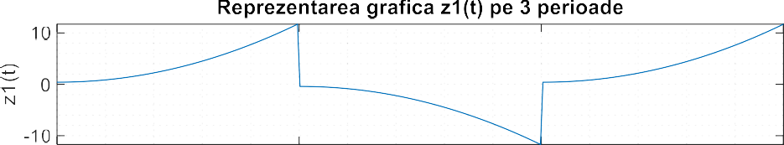

   



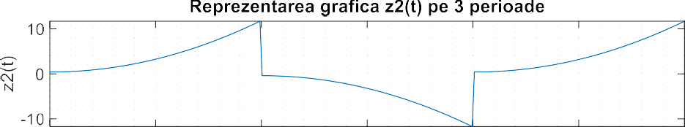

      



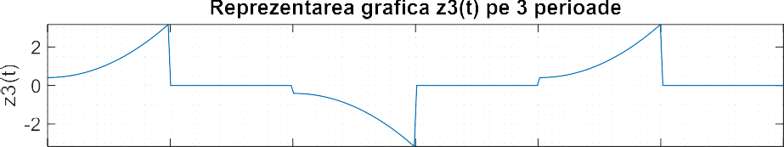

      



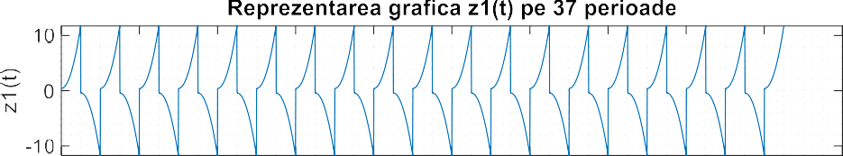

          

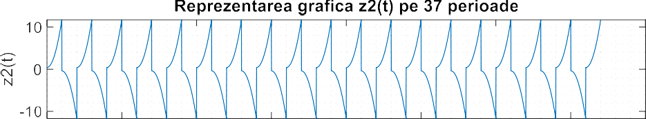

        



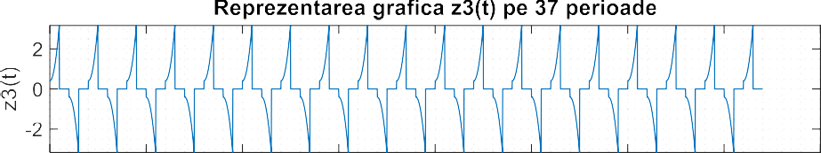

        



# monoalternanta si dubla alternanta

% xi monoalternate number_of_periods[3] = 20 => i = 3

mono.m

function [mono_signal] = mono(x, s) for i=1:1:length(s)

if (x(i)<0)

x(i)=0;

end

end

mono_signal = x; end

for j = 1:3

name = 'x';

signal = signal_main(a0, a1, a2, t1);

display_mono_signal(signal, T, j, 3, name, number_of_periods, period, @signal_xi, @mono);

end

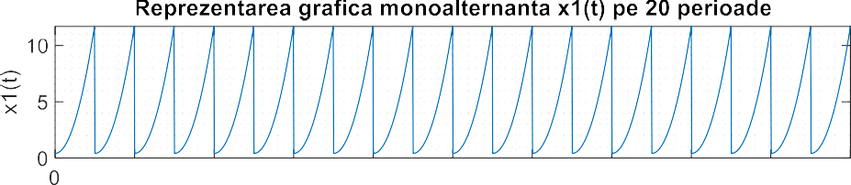



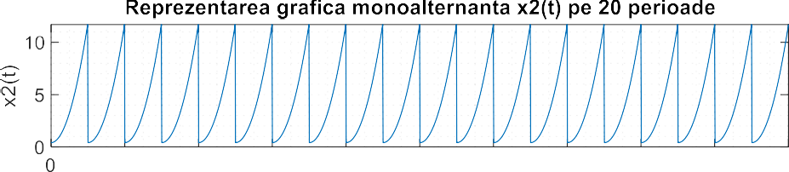



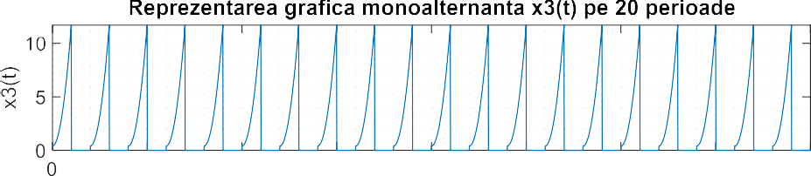



% yi monoalternate number_of_periods[3] = 20 => i = 3 for j = 1:3

name = 'y';

signal = signal_main(a0, a1, a2, t1);

display_mono_signal(signal, T, j, 3, name, number_of_periods, period, @signal_yi, @mono);

end

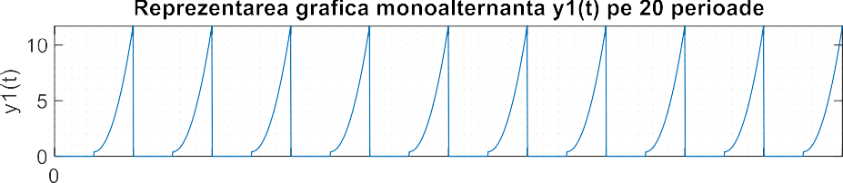



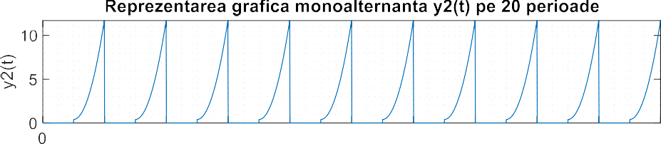



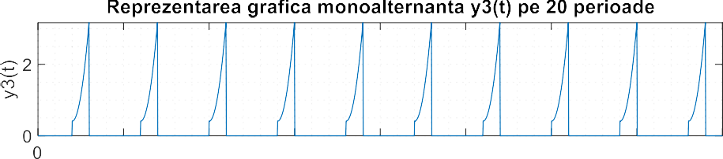



%zi monoalternate for j = 1:3

name = 'z';

signal = signal_main(a0, a1, a2, t1);

display_mono_signal(signal, T, j, 3, name, number_of_periods, period, @signal_zi, @mono);

end

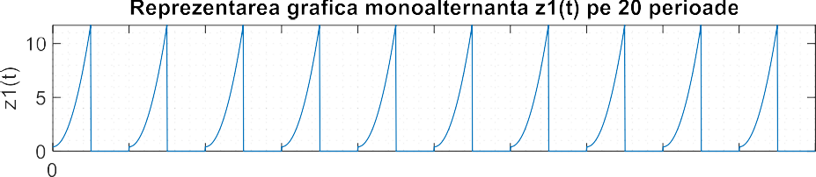



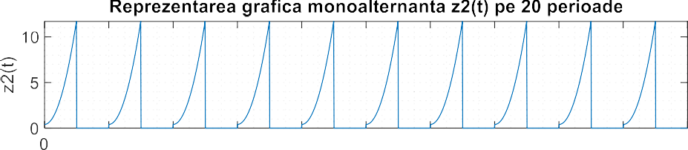



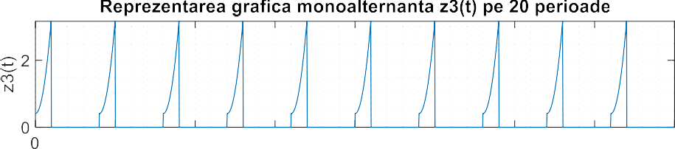



%xi double alternate for j = 1:3

double.m

function [double_signal] = double_(x, s) for i=1:1:length(s)

if (x(i)<0)

x(i)=-x(i);

end

end

double_signal = x; end

name = 'x';

signal = signal_main(a0, a1, a2, t1);

display_double_signal(signal, T, j, 3, name, number_of_periods, period, @signal_xi, @double_); end

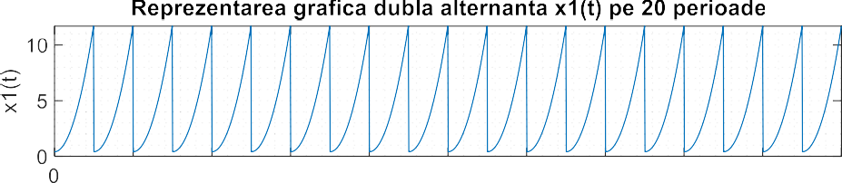



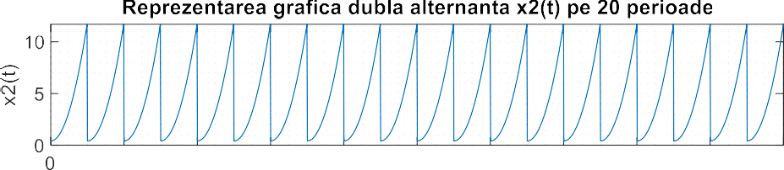



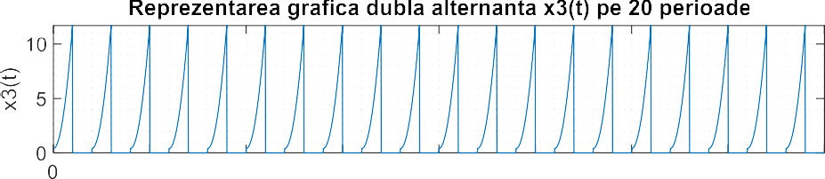



% yi double alternate for j = 1:3

name = 'y';

signal = signal_main(a0, a1, a2, t1);

display_double_signal(signal, T, j, 3, name, number_of_periods, period, @signal_yi, @double_);

end

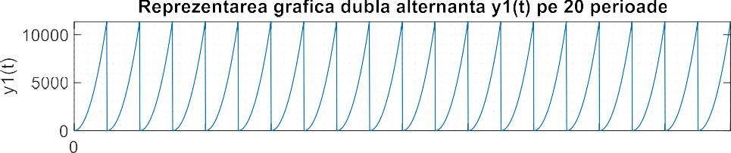



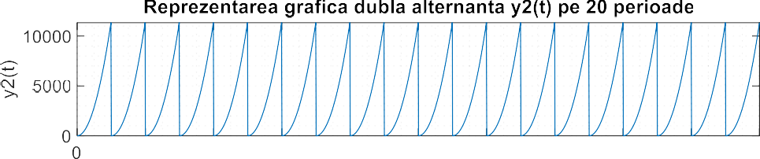



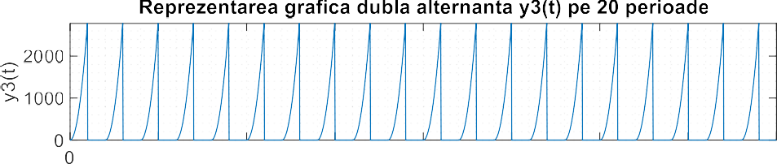



%zi double alternate for j = 1:3

name = 'z';

signal = signal_main(a0, a1, a2, t1);

display_double_signal(signal, T, j, 3, name, number_of_periods, period, @signal_zi, @double_);

end

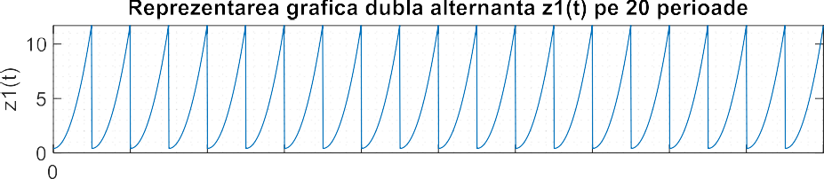



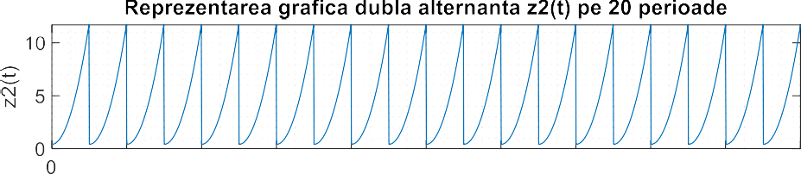



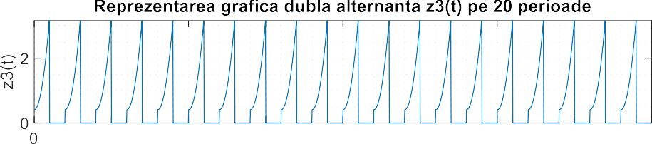



# xpar(t), ximpar(t), x(t/2), x(2t)…

% x par => a1 = 0 subplot(2, 1, 1);

Signal_second.m

function [x] = signal_second(a0, a1, a2, t)

% return the main signal any t x = a2*(t.^2) + a1 * t + a0; end

plot(s, signal_second(a0, 0, a2, s));

design_graph('t', 'x(t)', 'Reprezentarea grafica xpar(t)');

% x impar => a2 = 0 a1 = -a1 a0

= 0

subplot(2, 1, 2);

plot(s, signal_second(0, -a1, 0, s));

design_graph('t', 'x(t)', 'Reprezentarea grafica ximpar(t)');

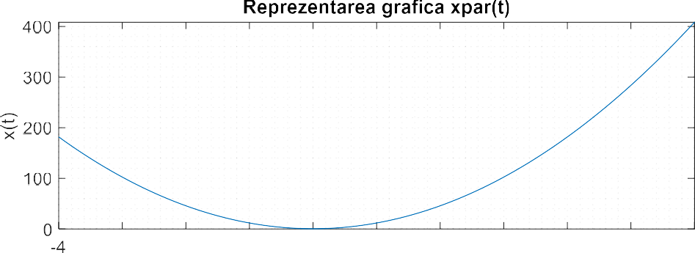



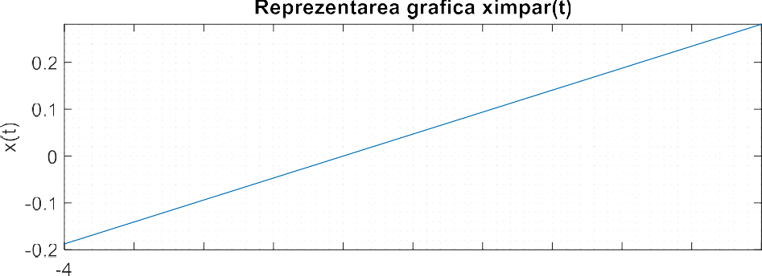



% x(2t) subplot(3, 1, 1);

plot(s, signal_second(a0, a1, a2, 2*s)); design_graph('t', 'x(t)', 'Reprezentarea grafica x(2t)');

% x(2t-1)

subplot(3, 1, 2);

plot(s, signal_second(a0, a1, a2, (2*s -1))); design_graph('t', 'x(t)', 'Reprezentarea grafica x(2t - 1)');

% x(t/2) subplot(3, 1, 3);

plot(s, signal_second(a0, a1, a2, s/2)); design_graph('t', 'x(t)', 'Reprezentarea grafica x(t/2)');

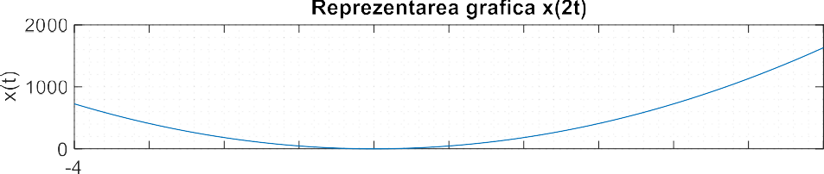



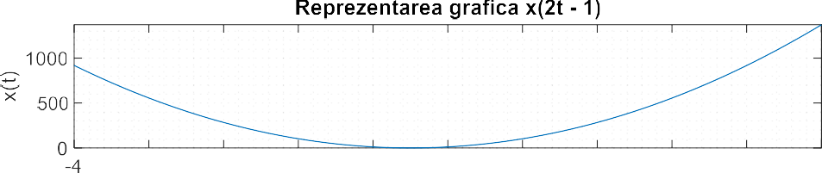



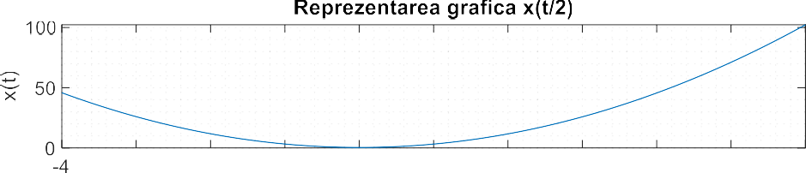



% x^2(t) subplot(3, 1, 1);

plot(s, signal_second(a0, a1, a2, s) .^ 2); design_graph('t', 'x(t)', 'Reprezentarea grafica x^2(t)');

% x^2(2t) subplot(3, 1, 2);

plot(s, signal_second(a0, a1, a2, 2 * s) .^ 2); design_graph('t', 'x(t)', 'Reprezentarea grafica x^2(2t)');

% x(sqrt(abs(2t)))

subplot(3, 1, 3);

plot(s, sqrt(abs(signal_second(a0, a1, a2, s)))); design_graph('t', 'x(t)', 'Reprezentarea grafica sqrt(x(t))');

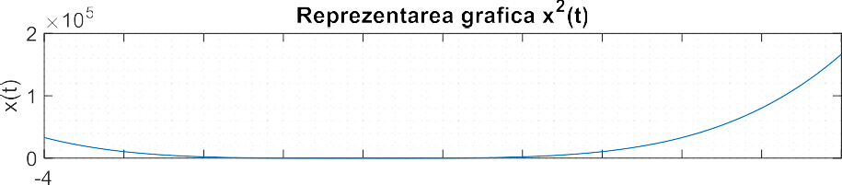



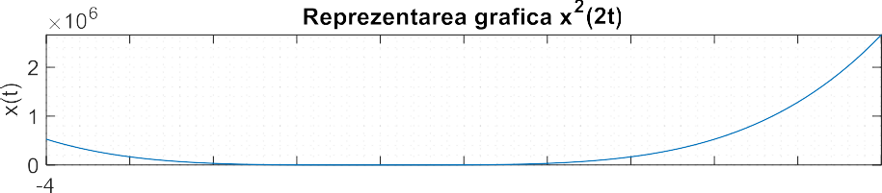



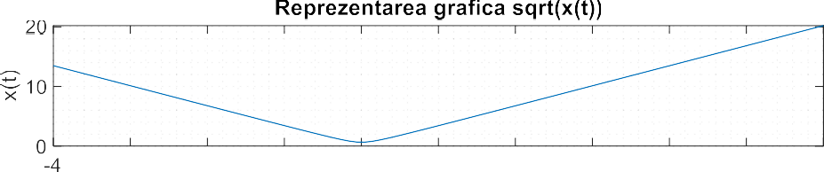



# Calcul analitic componenta continua

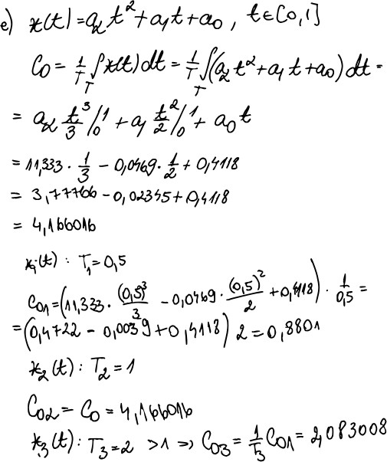

* 1. **xi(t), yi(t), zi(t) fara CC (yi, zi – impare => C0 = 0)**

% xi - CC for i = 4:5

for j = 1:3

name = 'x';

signal = signal_main(a0, a1, a2, t1);

display_signal_nocc(signal, T, j, i, name, number_of_periods, period, @signal_xi);

end input('next');

end

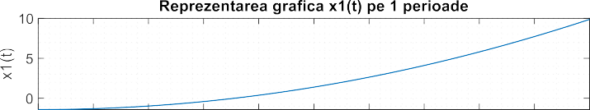

          



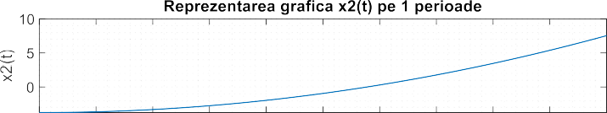

          



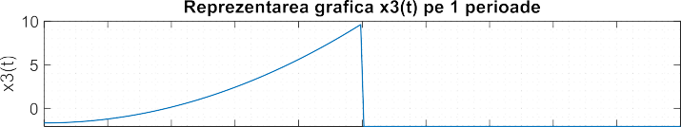

          



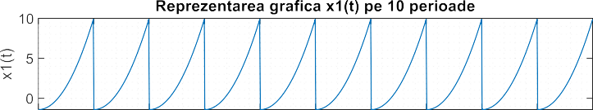

          



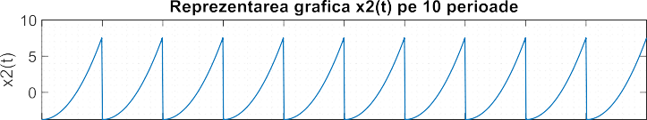

          



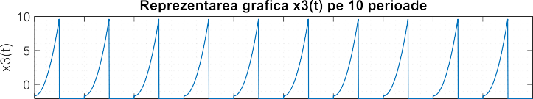

          



# Calculul componentei continue in matlab

cc.m

function [cc] = cc(x, precision, T) area = 0;

for i = 1:precision area = area + x(i);

end

cc = (1 / T) * area * (1/precision); end

% cc: precision = 10^5 for i = 1:3

disp(cc(signal_main(a0, a1, a2, precision_t), precision, T(i)));

end input('next');

# Pt

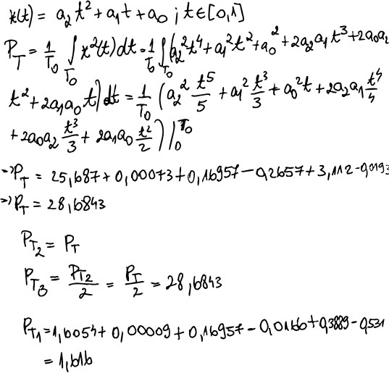

% pt: precision = 10^4 for i = 1:3

calculate_power.m

function [pt] = calculate_power(x, precision, T)

area = 0;

for i = 1:precision

area = area + (x(i).^2);

end

pt = (1 / T) * area * (1/precision); end

disp(calculate_power(signal_main( a0, a1, a2, pprecision_t), pprecision, T(i)));

end

# i) w1(t), w2(t), w3(t)

% w1(t) syms t;

tw1 = [n-4, n+12];

w1 = @(t) n*heaviside(t-n) - (n-17)*heaviside(t-n-4) + (2*n+15)*heaviside(t-n-7) - (30+2*n)*heaviside(t-n-9) - 2*heaviside(t-n-10);

fplot(w1(t), tw1);

y_label = 'w1(t)';

title_ = 'Reprezentarea grafica w1(t)'; design_graph('t', y_label, title_);



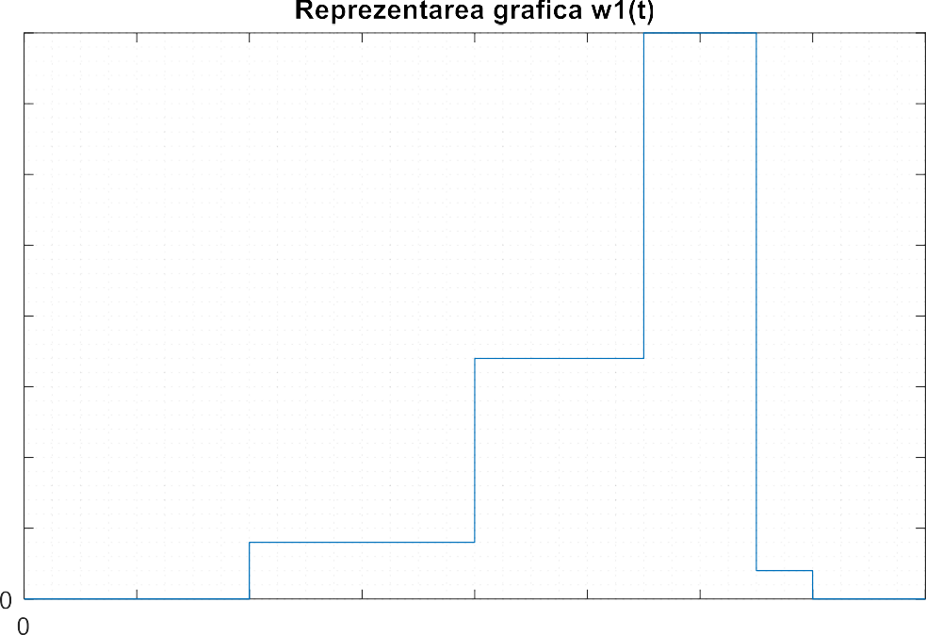



% w2(t) syms t;

tw2 = [-2, 11];

w2 = @(t) t*heaviside(t) + (n*t-20)*heaviside(t-2) - (n-10)*heaviside(t-5) - (n*t- 10)*heaviside(t-7);

fplot(w2(t), tw2);

y_label = 'w2(t)';

title_ = 'Reprezentarea grafica w2(t)'; design_graph('t', y_label, title_);



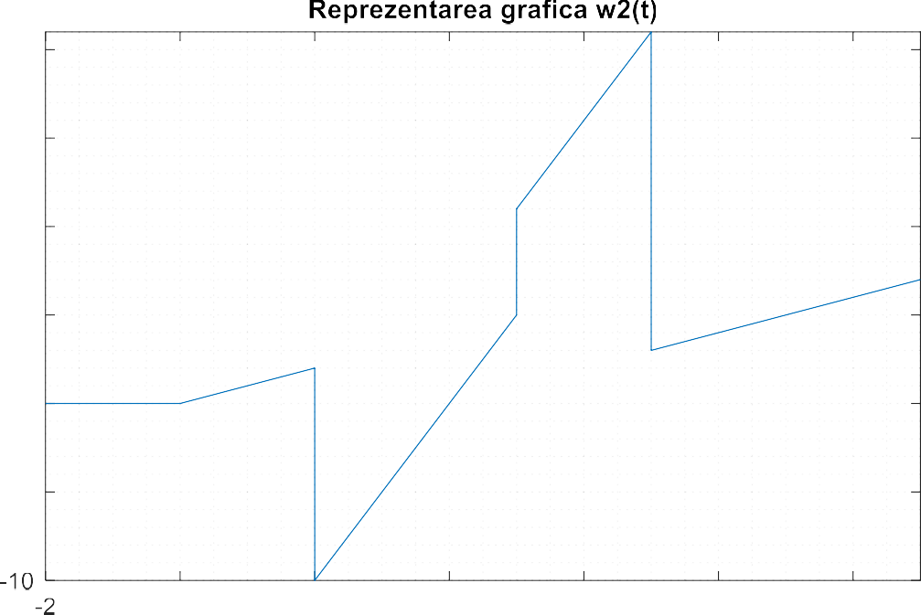





% w3(t) syms t;

tw3 = [-n, 6*n];

w3 = @(t) 5*heaviside(t-n) - 9*((t-3*n)/n)*(heaviside(t-2*n)-heaviside(t-3*n)) + 9*(1+(2*n-t)/n)*(heaviside(t-3*n)-heaviside(t-4*n)) - 5*heaviside(t-5*n); fplot(w3(t), tw3);

y_label = 'w3(t)';

title_ = 'Reprezentarea grafica w3(t)'; design_graph('t', y_label, title_);

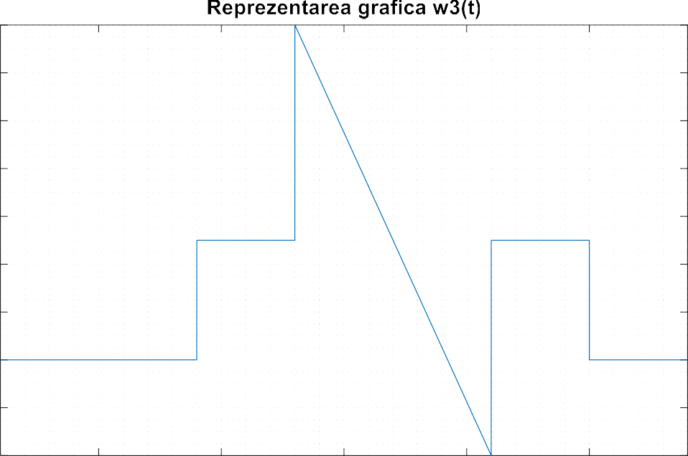input('next');





# Concluzii

# In acest proiect am reprezentat grafic, cu ajutorul platformei Matlab, semnale in diferite conditii. Cele 9 semnale initiale au fost ulterior modificate conform cerintelor, schimband nu numai definitia acestora, dar si suportul pe care au fost reprezentate.

# Limbajul de programare Matlab are functionalitati datorita carora gestionarea semnalelor poate fi simplificata. Un exemplu este variabila simbolica, care este foarte folositoare in definirea unui semnal dependent de timp.

# De asemenea, Matlabul ofera diferite metode de citire si prelucrarea a datelor, lucru care confera libertatea de a manevra cantitati mari de informatie.

# Reprezentarea vizuala a unei notiuni initial abstracte este un pas foarte important spre intelegerea cu adevarat a unui concept. Imbinarea semnalelor cu programarea antreneaza doua dintre calitatile principale necesare unui electronist.

# In concluzie, in urma realizarii acestui proiect, am aprofundat informatiile deja cunoscute despre semnale si sisteme si am dezvoltat abilitatile de programare, in special programarea functionala.

# Bibliografie

# <https://www.mathworks.com/help/matlab/>

# <https://www.wikipedia.org/>

# <https://www.techopedia.com/definition/14154/signal-electronics>

# <https://www.techtarget.com/searchnetworking/definition/signal>

# Cursul de „Semnale si Sisteme”